# Summary Report (07/17/2014)

## Distribution of the length of TA’s summary

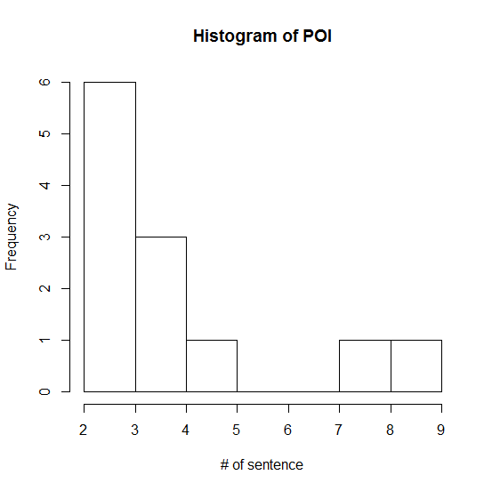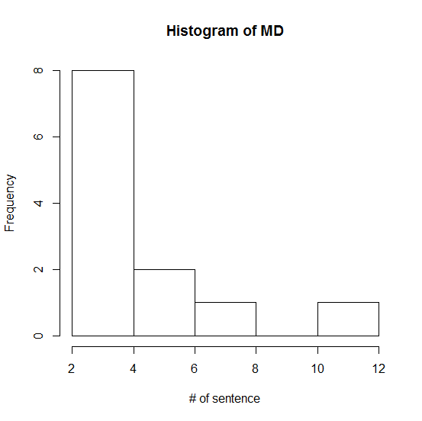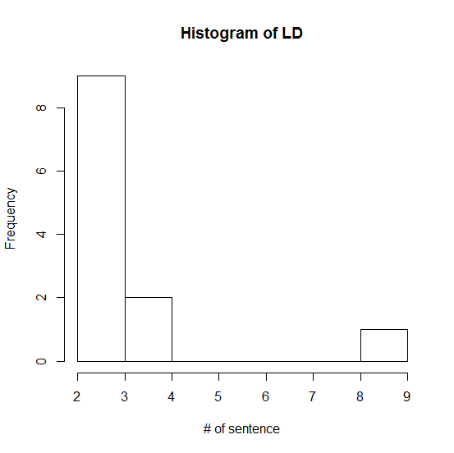

Most of them are 2 sentences or 3 sentences.

## The length of Mead’s Summary: # of words

The # of words in Mead’s summary is significantly different from TA’s summary (p-value is less than 0.001 using paired t-test)

|  |  |  |  |  |  |  |
| --- | --- | --- | --- | --- | --- | --- |
|  | word count | | | word count | | |
| Week | TA:POI | TA:MP | TA:LP | Mead:POI | Mead:MP | Mead:LP |
| 1 | 19 | 12 | 15 | 76 | 85 | 46 |
| 2 | 15 | 30 | 11 | 91 | 93 | 62 |
| 3 | 30 | 25 | 40 | 62 | 68 | 125 |
| 4 | 17 | 31 | 17 | 62 | 70 | 67 |
| 5 | 19 | 45 | 25 | 51 | 85 | 76 |
| 6 | 17 | 19 | 24 | 50 | 49 | 46 |
| 7 | 27 | 31 | 10 | 56 | 72 | 71 |
| 8 | 27 | 32 | 15 | 65 | 70 | 48 |
| 9 | 59 | 83 | 13 | 97 | 131 | 61 |
| 10 | 35 | 55 | 22 | 66 | 81 | 72 |
| 11 | 95 | 111 | 84 | 127 | 141 | 153 |
| 12 | 65 | 45 | 15 | 95 | 78 | 74 |

## Multiple-document summarization

Instead of concatenating all the students’ responses into one single document, each of the responses are one single document. Thus, it is a multiple document summarization task instead of single document summarization. The evaluation results are shown in the following sessions.

## Evaluation metric

### ROUGE-2

### ROUGE-SU4

## Results

Single-doc summarization vs. multi-doc summarization

## TODO